CST 352 – Lecture 5 File Systems part 1
Wilsonville, Spring 2022

Ch 6, Disks, Virtual FS

File Systems
Abstracts access to permanent storage devices for applications

Requirements:
- Easy access for applications
- Consistent and high performance read/write
- Permanence of data and crash resistance
- Security of data

For ease of access, OS proides an API
Abstracts away underlying storage medium
Typically consists of directories (aka folders) and files for structure, streams for reading/writing file contents

Performance requires tuning file system and underlying hardware abstractions for media
Different types of media have different performance characteristics (tape vs hard drive)
Different locations on same media have different performance (parts of tape or drive)

What happens when an application or the OS crashes?
Any data not yet committed to the disk will be lost
Can lead to application data loss or file system corruption

Applications and users should have access to only the data they are authorized for
File system must be integrated with OS’s security model (e.g. users/permissions)

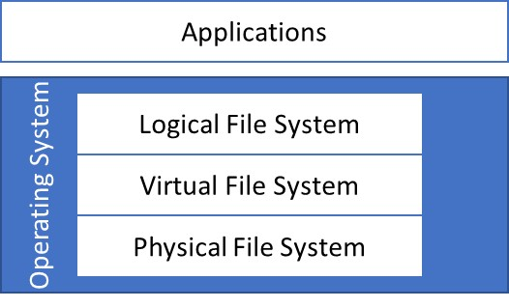

Logical File System – provides abstractions and API for applications
Virtual File System – integrates multiple physical file systems
Physical File System – handles storage mechanisms, including blocking

Example Storage – Hard Disks
HDD – hard disk drive

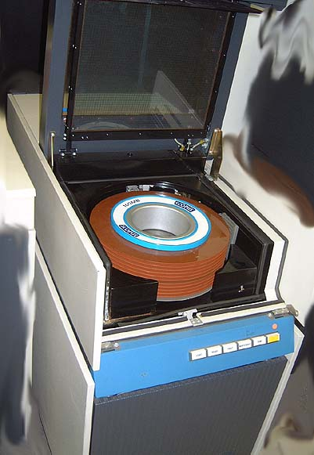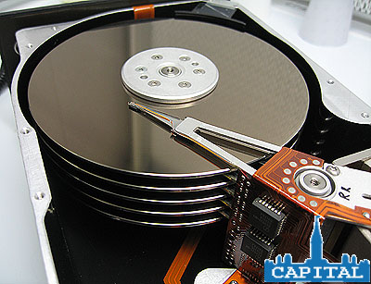
380 Mb hard drive with removable drive packs

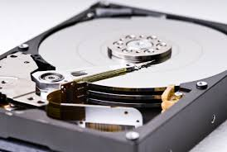
1 Tb hard drive

Platters, each with two surfaces, spinning rapidly (10,000+ RPMs)
Heads to read/write data, one per surface, positioned to access tracks
Track, on a platter, contains sectors
Cylinder is the vertical stack of sectors across all platters

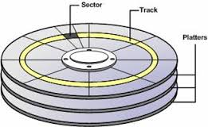

CHS addressing – Cylinder/Head/Sector → 8Mb max
Cylinders/Tracks (max 1024)
Heads (max 256, typically 2-4)
Sectors per track (typically 63)
Sector size (typically 512 bytes)

LBA – Logical Block Addressing
Just treat the disk as if it were in a gigantic array of sectors, starting at 0 (zero)

Latency
Seek time - position heads on cylinder
Rotational latency - rotate platters to desired sector (related to RPM)
Transfer time - read/write sector data
Different tracks have different latency

Disk driver
Controls hardware, give common API for OS to access different disk models
Cache entire tracks where possible/safe

SSD – solid state drive
Much higher performance, but more expensive

Logical File System
API for applications to interact with file system
Hides all the details of the physical storage and presents a common abstraction

Drives – a physical storage media (HDD, optical disk, tape, network drive)
Partitions – named portion of a drive
Directories – containers organized in a tree from a root directory down
Files – containers for data

Mounting drives makes the drive available in a named location (mount point)

Creating, moving, renaming, deleting files and directories
Opening files for read/write
Buffered access to the files

Virtual File System
Joins multiple physical file systems of various types into one common scheme

UNIX scheme: mount drives into the one directory tree, mount point appears as a directory name, somewhere under the root directory

Windows scheme: mount drives with a new drive letter

Physical File System
Encapsulates details of a physical file system and takes care of blocking data

Each underlying drive provides some number of sectors, with an addressing scheme
All file system data must be mapped to these sectors
Drive formatting requires applying an organization to the sectors
Typically basic structure is written to early sectors as an entry point

Basic metadata about each directory and file will be stored at some sector
Data will be “blocked” and written to a number of sectors
Directory blocks contain name/address pairs for each sub-directory and file
File blocks contains the actual file data

Need a scheme for knowing which sectors are used and which are free

Performance is a key consideration for the physical layer
How much of the underlying media will be used for organization vs data?
Which sectors will be used for directories and which for files?
Will contiguous sectors be used for contiguous blocks of file data?
How will the OS know which are contiguous and performance characteristics?
Which data will be cached for read/write?
How deal with hardware failures, e.g. “bad sectors”?

We’ll answer these in the next lecture

